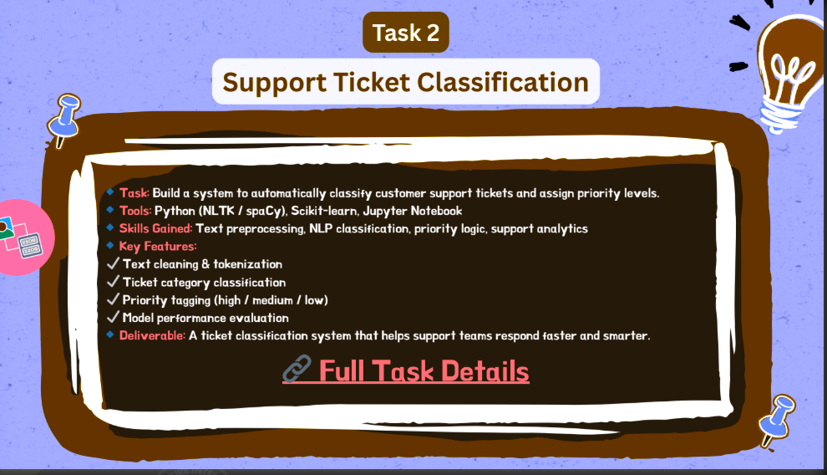

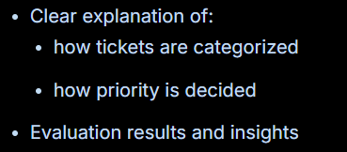

- HOW TICKETS ARE CATEGORIZE

The system automatically categorizes support tickets using Natural Language Processing (NLP) and Machine Learning.
It follows a step-by-step process:

1. Ticket Text is Read
The system first reads the ticket description written by the customer.
Example:
"My payment was deducted but my order is not confirmed."
This is the raw input.

2. Text Cleaning
The text is cleaned before analysis.
Cleaning includes:
- Converting text to lowercase
- Removing punctuation
- Removing numbers
- Removing common words (like "the", "is", "and")
Example:
Before cleaning:
"My payment was deducted but order not confirmed!!!"
After cleaning:
payment deducted order confirmed
This helps the model focus on important words.

3. Text Converted Into Numbers (TF-IDF)
Machine Learning models cannot understand text directly.
So the cleaned text is converted into numerical features using TF-IDF vectorization.
TF-IDF measures how important each word is in a ticket.
Example:
Word | Importance Score
payment | 0.82
deducted | 0.65
order | 0.40
This converts text into a mathematical representation.

4. Machine Learning Model Predicts Category
A Logistic Regression model analyzes the numerical features and predicts the ticket category.
The model learns patterns from past tickets.
Example patterns learned:
- Words like payment, refund, charge → Billing Inquiry
- Words like error, login, crash → Technical Issue
- Words like cancel, return → Cancellation Request
- Words like product details → Product Inquiry
Example prediction:
Input Ticket:
"My payment failed and money was deducted"
Prediction:
Category: Billing Inquiry

5. Output Category
The final predicted category is assigned automatically.
Example categories:
- Billing Inquiry
- Technical Issue
- Product Inquiry
- Cancellation Request
This allows support teams to quickly route tickets to the correct department.

Simple One-Line Explanation (Best for Viva)
If someone asks you:
"How are tickets categorized?"
Say:
Support tickets are categorized using NLP and Machine Learning. The ticket text is cleaned, converted into numerical features using TF-IDF, and then a Logistic Regression model predicts the category based on patterns learned from previous tickets.

- HOW PRIORITY IS DECIDED

The system automatically assigns High, Medium, or Low priority to support tickets using Machine Learning and NLP techniques.
It follows these steps:

1. Ticket Description is Analyzed
The system reads the customer’s ticket description.
Example:
"My account is locked and I cannot access my services."
The ticket text contains clues about urgency and severity.
For example:
- "not working"
- "failed"
- "error"
- "urgent"
- "cannot access"
These words often indicate higher priority issues.

2. Text Cleaning
The ticket text is cleaned before processing.
Cleaning includes:
- Lowercasing text
- Removing punctuation
- Removing numbers
- Removing stopwords
Example:
Before cleaning:
"My account is locked and I cannot login!!!"
After cleaning:
account locked cannot login
This keeps only meaningful words.

3. Text Converted to Numerical Features
The cleaned text is converted into numbers using TF-IDF vectorization.
Example:
account locked login
Becomes something like:
[0.72, 0.65, 0.48, 0.00, 0.91]
This allows the Machine Learning model to analyze patterns.

4. Machine Learning Model Predicts Priority
A Logistic Regression model predicts priority based on patterns learned from previous tickets.
The model learns relationships such as:
High Priority Examples
- "server down"
- "payment failed"
- "account locked"
- "system crash"
Medium Priority Examples
- "slow performance"
- "delayed delivery"
Low Priority Examples
- "product information"
- "general question"
Example:
Input ticket:
"My payment failed and money was deducted"
Prediction:
Priority: High

5. Final Priority Assignment
The system automatically assigns:
- High Priority → Urgent problems needing immediate action
- Medium Priority → Important but not urgent issues
- Low Priority → General inquiries or minor issues
This helps support teams handle urgent tickets first.

Short Answer (Best for Viva)
If asked:
"How is priority decided?
Say:
Ticket priority is decided using a Machine Learning model that analyzes ticket text. The text is cleaned and converted into numerical features using TF-IDF, and a Logistic
Regression model predicts whether the ticket should be High, Medium, or Low priority based on patterns learned from past support tickets.

